**Java switch Statement**

In this tutorial, you will learn to use the switch statement in Java to control the flow of your program’s execution with the help of examples.

The switch statement allows us to execute a block of code among many alternatives.

The syntax of the switch statement in Java is:

switch (expression) {

case value1:

// code

break;

case value2:

// code

break;

...

...

default:

// default statements

}

**How does the switch-case statement work?**

The expression is evaluated once and compared with the values of each case.

* If expression matches with value1, the code of case value1 are executed. Similarly, the code of case value2 is executed if expression matches with value2.
* If there is no match, the code of the **default case** is executed.

**Note**: The working of the switch-case statement is similar to the [Java if...else...if ladder](https://www.programiz.com/java-programming/if-else-statement#if-else-ladder). However, the syntax of the switch statement is cleaner and much easier to read and write.

**Example: Java switch Statement**

// Java Program to check the size

// using the switch...case statement

class Main {

public static void main(String[] args) {

int number = 44;

String size;

// switch statement to check size

switch (number) {

case 29:

size = "Small";

break;

case 42:

size = "Medium";

break;

// match the value of week

case 44:

size = "Large";

break;

case 48:

size = "Extra Large";

break;

default:

size = "Unknown";

break;

}

System.out.println("Size: " + size);

}

}

[Run Code](https://www.programiz.com/java-programming/online-compiler)

**Output**:

Size: Large

In the above example, we have used the switch statement to find the size. Here, we have a variable number. The variable is compared with the value of each case statement.

Since the value matches with **44**, the code of case 44 is executed.

size = "Large";

break;

Here, the size variable is assigned with the value Large.

**Recommended Reading**: [Create a Simple Calculator Using the Java switch Statement](https://www.programiz.com/java-programming/examples/calculator-switch-case)

**Flowchart of switch Statement**

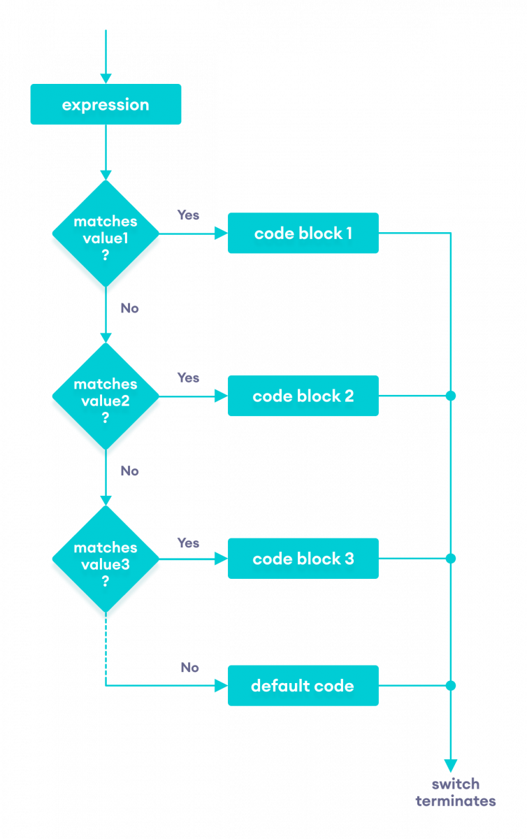Flow chart of the Java switch statement

**break statement in Java switch...case**

Notice that we have been using break in each case block.

...

case 29:

size = "Small";

break;

...

The break statement is used to terminate the **switch-case** statement. If break is not used, all the cases after the matching case are also executed. For example,

class Main {

public static void main(String[] args) {

int expression = 2;

// switch statement to check size

switch (expression) {

case 1:

System.out.println("Case 1");

// matching case

case 2:

System.out.println("Case 2");

case 3:

System.out.println("Case 3");

default:

System.out.println("Default case");

}

}

}

[Run Code](https://www.programiz.com/java-programming/online-compiler)

**Output**

Case 2

Case 3

Default case

In the above example, expression matches with case 2. Here, we haven't used the break statement after each case.

Hence, all the cases after case 2 are also executed.

This is why the break statement is needed to terminate the **switch-case** statement after the matching case. To learn more, visit [Java break Statement](https://www.programiz.com/java-programming/break-statement).

**default case in Java switch-case**

The switch statement also includes an **optional default case**. It is executed when the expression doesn't match any of the cases. For example,

class Main {

public static void main(String[] args) {

int expression = 9;

switch(expression) {

case 2:

System.out.println("Small Size");

break;

case 3:

System.out.println("Large Size");

break;

// default case

default:

System.out.println("Unknown Size");

}

}

}

[Run Code](https://www.programiz.com/java-programming/online-compiler)

**Output**

Unknown Size

In the above example, we have created a **switch-case** statement. Here, the value of expression doesn't match with any of the cases.

Hence, the code inside the **default case** is executed.

default:

System.out.println("Unknown Size);